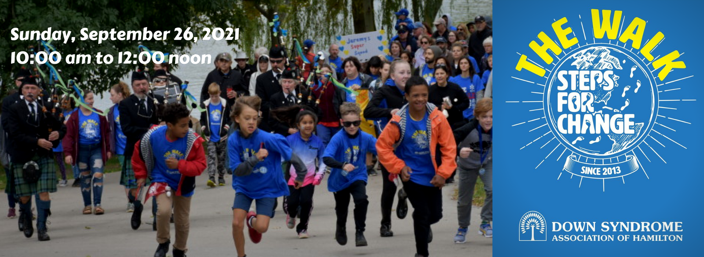

We are happy to announce that the 2021 DSAH Walk is officially open! The Walk is the association’s primary fundraising event, and we are happy to report that even during the pandemic, the strength and support of and for our community has continued! On Sunday, September 26, join us for a Virtual Walk. The event will begin with a Kick‐off Ceremony at 10am to connect over Zoom and share the successes of the last year. After the countdown, teams will be encouraged to walk together but apart and post their photos using #dsahwalk.

Setting up at Team page (also known as a Fundraiser!)
You can set up a team page using a two‐step process in the Canada Helps platform.
Step 1: Click, or copy and paste on your web browser, the Walk Page link: https://www.canadahelps.org/en/charities/the-down-syndrome-association-of-hamilton/p2p/the-walk/
Find the “Create a Fundraiser” button and click it.
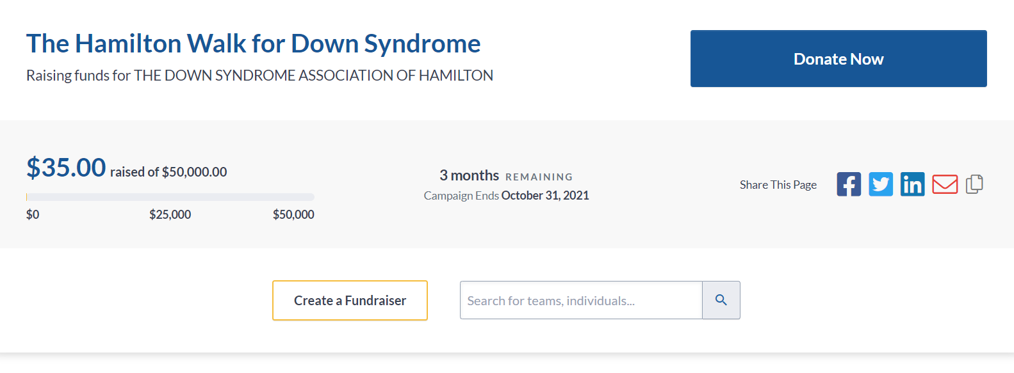

You will be directed to a page titled “Join The Hamilton Walk for Down Syndrome”
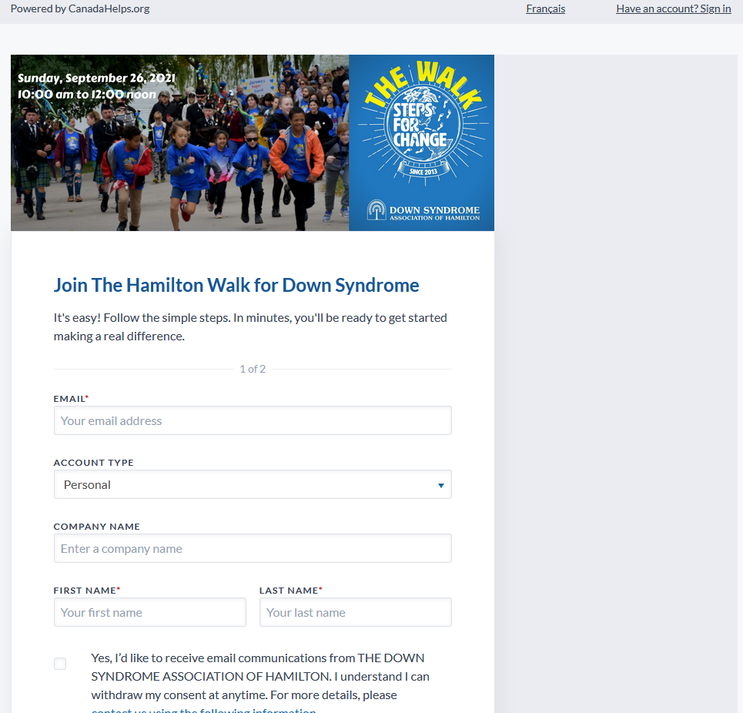
Follow the steps with entering and confirming your email address to create an account. If you are new to Canada Helps, and do not have an account, you will be asked to “Create an Account”. A small box will prompt you to enter your chosen password. Once complete, click “Create Account”.

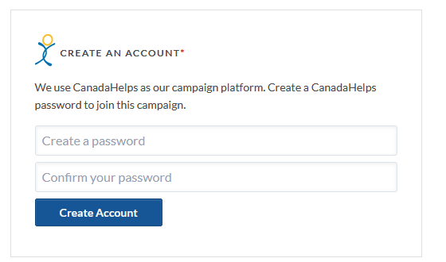

You will be asked to select an account type – most participants can choose the “Personal” Account Type. There is no need to enter a company name. You will need to enter your First and Last Name. You can opt‐in to our email list to receive our newsletters, etc. When you are ready, click “Continue”.
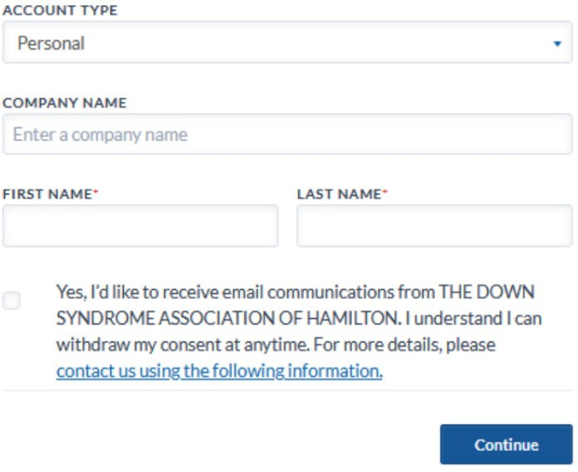

ready,

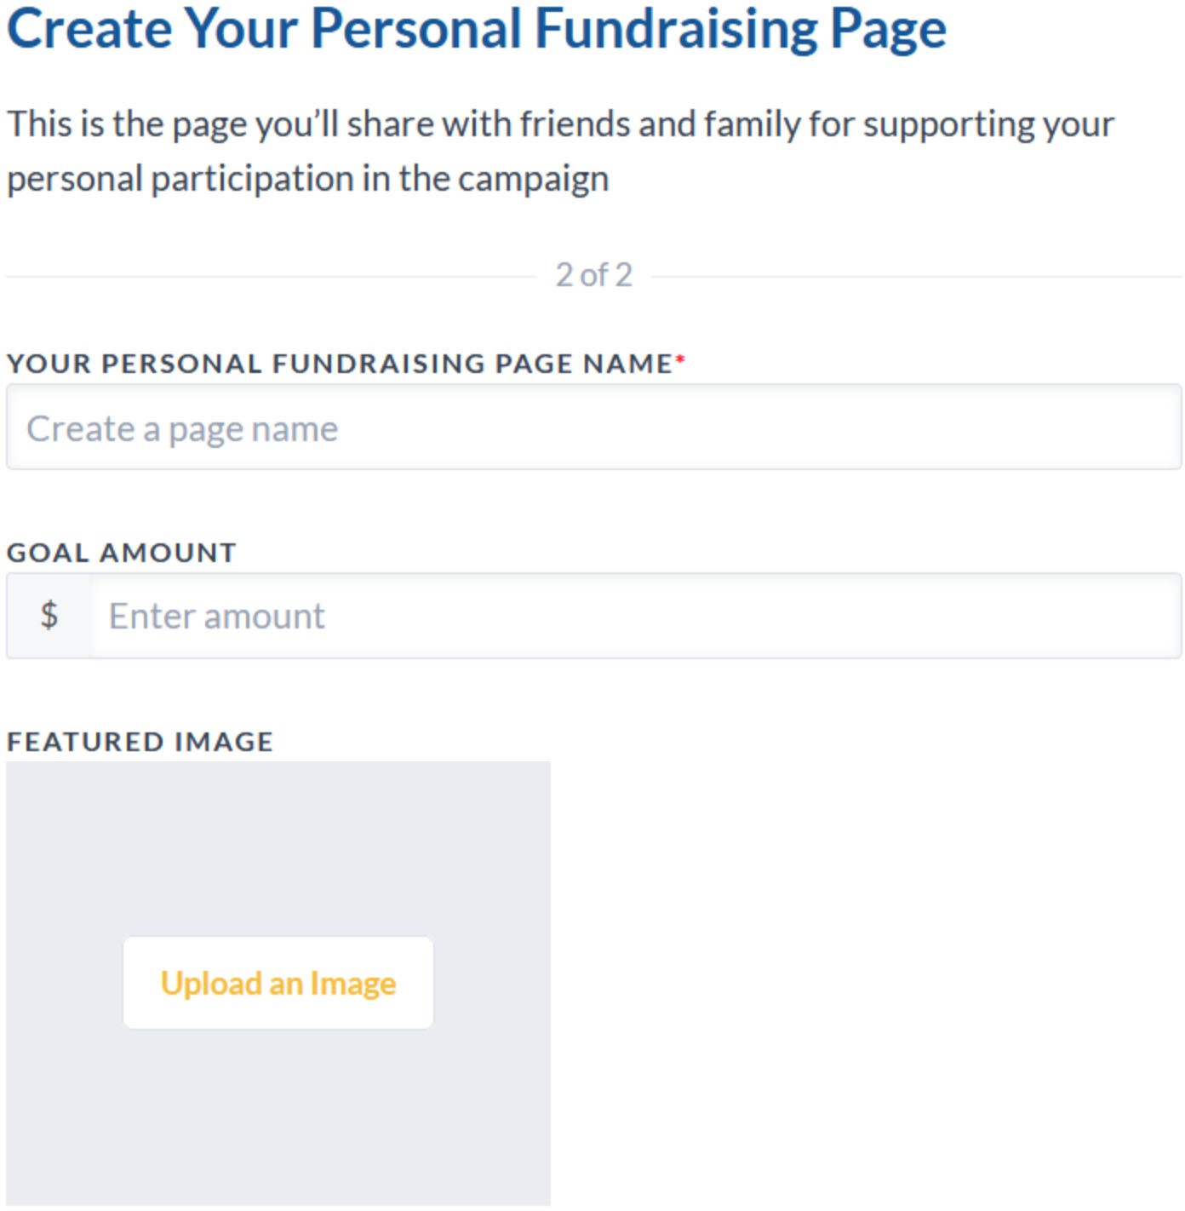
Step 2 is where you can “Create Your Personal Fundraising Page”

Give your page the name you want for your Team name and that your supporters will recognize (e.g., Team Muschta).

Choose your goal amount to strive toward. Please consider adding a photo so your supporters can see who they want to support, if they are not familiar with your team name.
You can also include a brief “Fundraising Story” to share why you will be walking with us this year (e.g., I Walk for Team X to raise awareness and support for DSAH).
When you click continue, you will access your unique fundraising page. Here, you can edit the information of your fundraising page.
You will find your unique link to copy and send to your supporters. You will receive an email from Canada Helps with your information. Save that email and remember that you can always log back into your personal fundraiser and make changes to your page (e.g., your Goal Amount, adding a new picture, etc.).
GENERAL TIPS
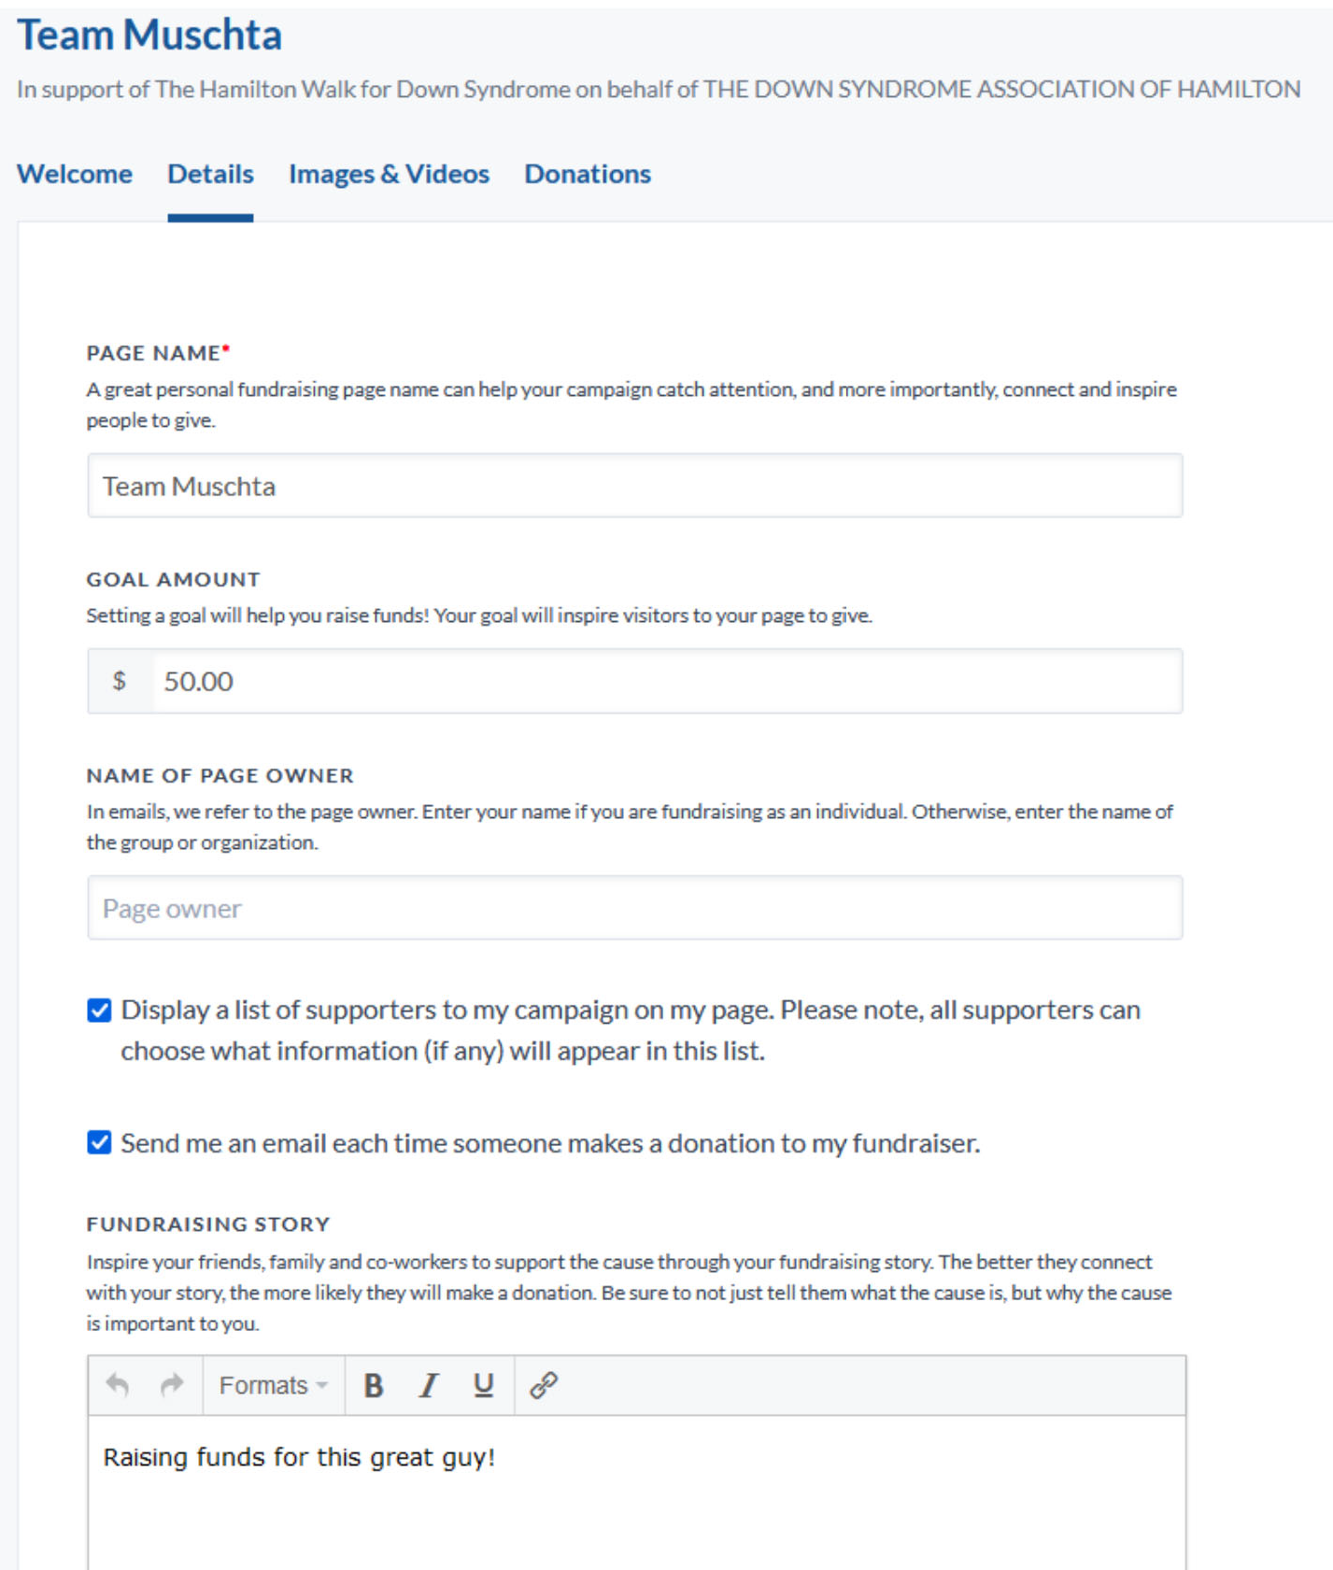
For best results, please use portrait orientation for photos and follow the guidelines for the size of the photo.
Please note that there is an option to receive email notifications EVERY time a donation is received.
Please make sure you check off whether or not you want to receive email notifications for these new donations. This option is found under the ‘Details’ tab.
Let your donors know they will receive an email with the electronic income tax receipt immediately following the donation – have them check their junk mail for the receipt if they cannot find it.
Stayed tune for more information about our awareness event and we hope to see you “Walk with Us” on Sunday, September 26 at 10am!

